Clinician Insights
NHS Healthcare | Azure Data Engineering Project

Project Introduction

Clinician Insights is an NHS healthcare Data Engineering and analytics platform designed to centralize data from multiple healthcare systems. It provides a unified view of clinicians, patients, hospitals, practices, clinical registries, diagnosis information and geographical regions. The platform supports clinician performance analysis and fair benchmarking by considering speciality, provider size, region, patient population and clinical activity.

Business Context & NHS Healthcare Hierarchy

LEVEL | BUSINESS ENTITY
1 | NHS / National Healthcare Level
2 | Region / Geography
3 | Healthcare Organisation / Trust
4 | Hospital or Provider (Large / Medium / Small)
5 | Practice / Clinical Service
6 | Clinician
7 | Patient

Problem Statement

  - Healthcare data is distributed across patient systems, clinician systems, hospital and practice systems, clinical registries and reference datasets.
  - Different systems use different formats, identifiers and coding standards.
  - Business users do not have a single, trusted view of clinician, patient and provider performance.
  - Comparing clinicians without considering hospital size, region, speciality and patient population can produce misleading insights.
  - Manual reporting and fragmented datasets make it difficult to identify trends, performance gaps and regional variations.

Business Objectives

  - Centralize healthcare data from multiple source systems.
  - Create a unified 360-degree view of clinicians, patients and healthcare providers.
  - Standardize clinical and diagnosis information using reference data such as ICD codes where applicable.
  - Enable clinician, hospital and practice performance analysis.
  - Support regional and geography-based healthcare insights.
  - Provide fair benchmarking across similar clinicians and providers.
  - Create trusted Gold-layer datasets for Synapse and Power BI reporting.

Clinician Insights — Architecture
Supplied project architecture diagram
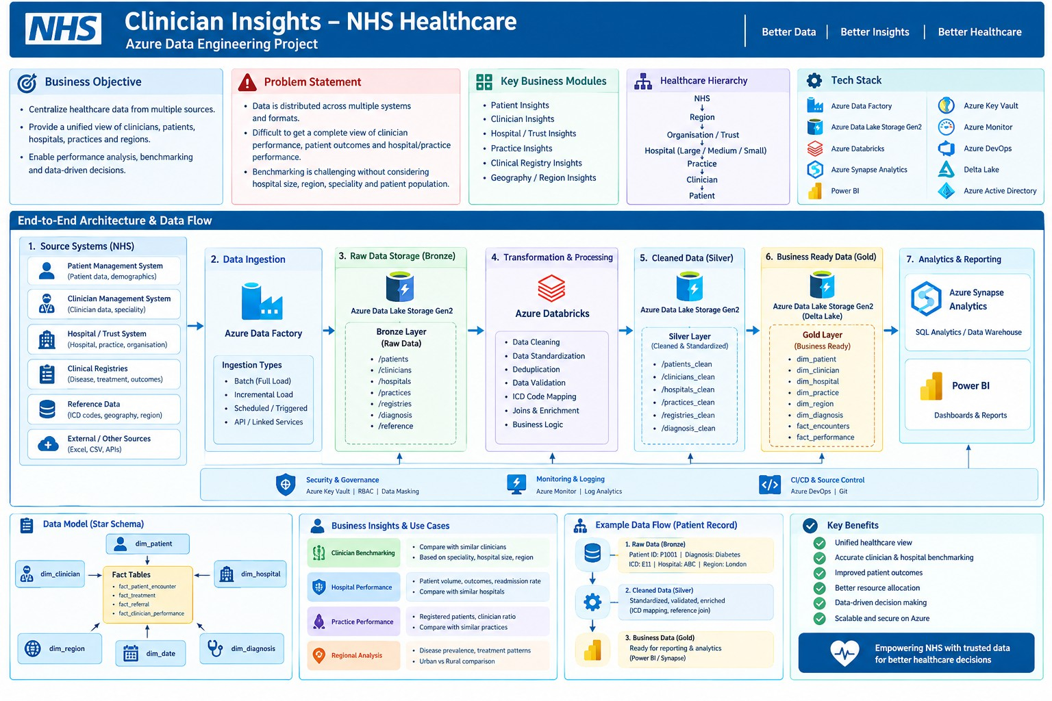
Clinician Insights — NHS healthcare Azure architecture and end-to-end data flow
Architecture path

Healthcare Sources → Azure Data Factory → ADLS Gen2 Bronze → Azure Databricks / PySpark → Silver / Delta
→ Gold / Delta → Synapse Analytics → Power BI

Clinician Insights — Data & Role
Source systems, processing, data model and responsibilities.

Source Systems & Core Data Entities

SOURCE / DOMAIN | TYPICAL DATA
Patient Management | Patient ID, demographics, geography, registered practice.
Clinician Management | Clinician ID, speciality, organisation and clinical role.
Hospital / Trust | Provider ID, provider type, location, capacity and organisation hierarchy.
Practice Systems | Practice ID, registered patients, clinicians and services.
Clinical Registries | Disease, treatment, clinical activity and outcome data.
Reference Data | ICD codes, geography, region, organisation classifications and code mappings.
External / APIs | Approved supplementary datasets or benchmark/reference information.
- Bronze → Silver → Gold

LAYER | IMPLEMENTATION
Bronze | Source-preserved healthcare data including patients, clinicians, hospitals, practices, registries, diagnoses and reference data.
Silver | Duplicate removal, null handling, identifier/date standardization, record validation, geography mapping, provider classification, ICD/reference mapping and enrichment.
Gold | Business-friendly facts and dimensions for clinician performance, patient encounters, provider insights, benchmarking and regional analytics.

Business Data Model

DIMENSIONS | FACTS
dim_patient | fact_patient_encounter
dim_clinician | fact_treatment / clinical_activity
dim_hospital / dim_provider | fact_referral
dim_practice | fact_clinician_performance
dim_region | fact_provider_performance
dim_diagnosis | fact_benchmark_metrics
dim_date

My Role and Responsibilities as a Data Engineer

  - Worked with business and analytics teams to understand clinician insights and healthcare reporting requirements.
  - Developed Azure Data Factory pipelines for ingesting data from multiple source systems.
  - Designed data lake folder structures and implemented Bronze, Silver and Gold layers.
  - Developed Azure Databricks notebooks using PySpark and Spark SQL.
  - Implemented data cleaning, standardization, validation and enrichment logic.
  - Performed joins across patient, clinician, provider, practice, registry and reference datasets.
  - Implemented incremental loading using watermark or last-modified strategies.
  - Created Delta tables and merge/upsert patterns for curated datasets.
  - Implemented data quality checks and exception handling.
  - Optimized Spark workloads through efficient transformations and appropriate partitioning.

  - Integrated Azure Key Vault for secure secret management.
  - Supported monitoring, troubleshooting and deployment through Azure Monitor and Azure DevOps.
  - Prepared Gold-layer datasets for Azure Synapse Analytics and Power BI reporting.

PROJECT 03

Clinician Insights — Interview Discussion
Questions are kept concise and project-focused, following the format of the supplied interview document.

Q1. What is Clinician Insights?
Clinician Insights is an NHS healthcare Data Engineering and analytics platform designed to centralize data from multiple healthcare systems. It provides a unified view of clinicians, patients, hospitals, practices, clinical registries, diagnosis information and geographical regions, supporting clinician performance analysis, fair benchmarking and data-driven healthcare decisions.

Q2. What was the main business problem?
Healthcare data was distributed across patient, clinician, hospital, practice, registry and reference systems. Different systems used different formats, identifiers and coding standards. Business users lacked a single trusted view of clinician, patient and provider performance, and fair benchmarking required consideration of speciality, provider size, region and patient population.

Q3. Explain the architecture.
Healthcare Sources → Azure Data Factory → ADLS Gen2 Bronze → Azure Databricks / PySpark → Silver / Delta → Gold / Delta → Synapse Analytics → Power BI. Raw source data is preserved in Bronze, standardized and validated in Silver, and transformed into business-ready models in Gold.

Q4. How did you handle incremental loading?
Initial loads contain historical data. Subsequent loads process only new or changed records using a watermark,
last-modified timestamp or other source-supported change tracking approach. The flow is: Get watermark → Extract new/changed records → Bronze → Validate → Silver → Merge/Upsert Gold → Update watermark → Monitor.

Q5. What were your responsibilities?
My role included ADF pipelines, data lake structures and Bronze/Silver/Gold layers, Databricks notebooks using PySpark and Spark SQL, cleaning and standardization, joins across healthcare datasets, incremental loading, Delta tables, data quality, Spark optimization, Key Vault, monitoring, Azure DevOps deployment and Gold datasets for Synapse and Power BI.

PROJECT REFERENCE

Three Projects at a Glance
A concise comparison for selecting the right project during an interview.

AREA | CUSTOMER RETENTION | BUSINESS INTERRUPTION | CLINICIAN INSIGHTS
Domain | Customer analytics / retention | Insurance – commercial / BI | Healthcare / NHS
Main goal | Customer 360, engagement, churn and segmentation | Policy, claims, premium, risk and retention analytics | Clinician insights, fair benchmarking and regional analysis
Key data | Customer, transactions, events | Customer, policy, coverage, claims, premium, risk | Patient, clinician, provider, practice, registry, diagnosis, region
Primary analytics | Customer 360 • churn • engagement | Policy • claims • premium • retention | Performance • benchmarking • patient / regional trends
Core platform | ADF • ADLS • Databricks • Delta • Synapse • Power BI | ADF • ADLS • Databricks • Delta • Synapse • Power BI | ADF • ADLS • Databricks • Delta • Synapse • Power BI

Project Selection During Interview

IF THE QUESTION IS ABOUT… | USE THIS PROJECT
Customer 360 / churn / engagement | Customer Retention Analytics
Policy / claims / premium / insurance retention | Business Interruption Insurance
Healthcare / clinician / provider / benchmarking | Clinician Insights
Azure Lakehouse / ADF / Databricks / Delta | Any of the three; use the project domain that matches the question
Incremental loading / data quality / Spark optimization | Use the detailed implementation from the relevant project
Architecture to remember

ADF → ADLS Gen2 → Databricks / PySpark → Delta → Synapse → Power BI
Prepared from the supplied Customer Retention Analytics, Business Interruption Insurance, Clinician Insights and interview-format documents. Timed-answer labels and the generic quick-question appendix have been intentionally left out.

